A How to Guide!

How to Create a Youth-2-Youth Panel on Healthy Coping
“We are Still Learning Too”

Created and Developed by 2019 Teens for Tomorrow Peer Educators,
Clark County Community Services

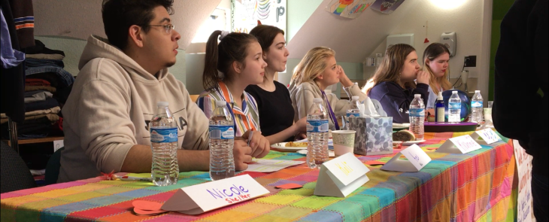
Contents
Title: We Are Still Learning Too: A Youth-2-Youth Panel on Healthy Coping 2
Note to Panel and Moderator 4
Moderator Script 5
Tips for Panelists 9
Tips for Moderator(s) 11
Pre/Post Survey 13

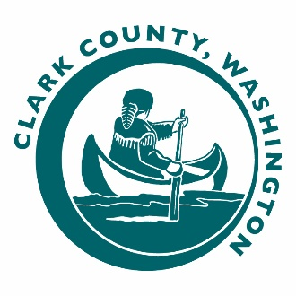
We Are Still Learning Too:

A Youth-2-Youth Panel on Healthy Coping

Panel description: In this panel we wished to provide the youth in our community a way to persevere through any emotional or physical tribulation a person is currently going through. All while staying away from drugs and alcohol. We reviewed our 2016 Healthy Youth Survey data and learned a large portion of our youth in the community experience depression and anxiety. This information worried us when we read it and we wanted to do something about it, so that is why we did a panel on healthy coping.
- 35% of local 10th graders report depressive feelings
- 64% of local 10th graders report experiencing anxiety

The goals of the panel are to share resources, help youth identify a supportive adult, identify one short-term and one long-term coping skill, feel more comfortable sharing real struggles with safe people and asking for support.

Youth want to hear stories from other teens and want to know they’re not alone. Hearing stories from adults is important, but hearing stories from other teens can be empowering. This panel allows just that! This panel is about helping youth cope during tough times without using substances and allows for youth to learn from other youth.

Outcomes to expect: In this guide you will find a Pre and Post Survey we created to track your outcomes. Some of our outcomes from audience members can be seen in the bar graph below.

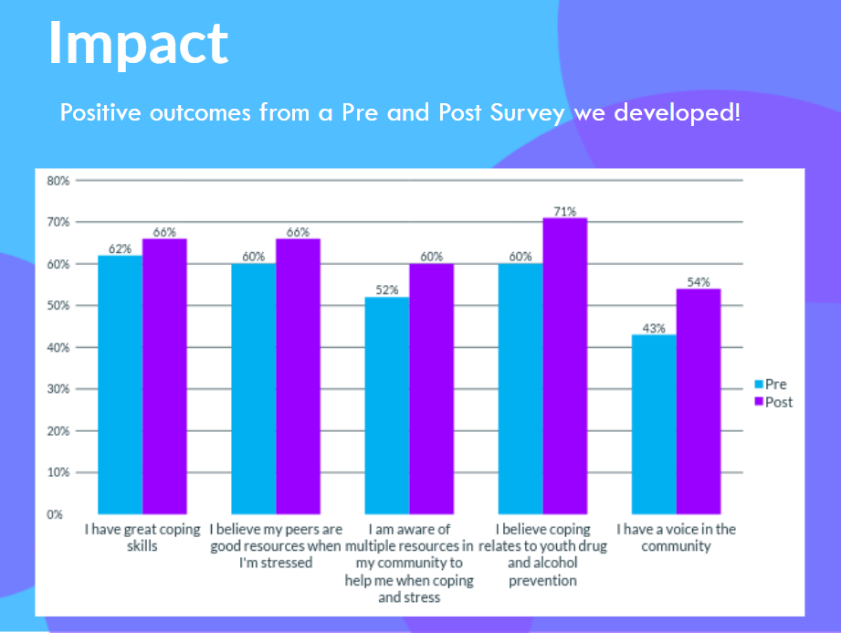
Unexpected Outcomes: We impacted ourselves the most! We shared the data with you earlier about youth experiencing anxiety and depression and not having an adult to turn to and some of us in the group relate to that.

We took the pre- and post-survey too and it turns out we learned a great deal. The biggest areas of growth for us was being able to tell when we are stressed, which increased by 26%, and being aware of resources, which increased by 32%

We learned from each other as we developed the panel, practiced answering questions, speaking, reflecting, sharing, learning from each other and our peers. It made us think about coping this WHOLE YEAR.

A quote from a Teens for Tomorrow member

“I have struggled my entire life with being open and vulnerable. I have always felt like the pistachio in the bag you just could never crack. But, through being apart of this project I have come to realize the only way to heal from the pain of my past and move on with life is to be open with people and accept their help. This experience has helped me to realize that one of the greatest superpowers a person can have is the strength to be vulnerable to help others and ourselves find the joy that life can bring.”

Here are more of the outcomes we had on ourselves:

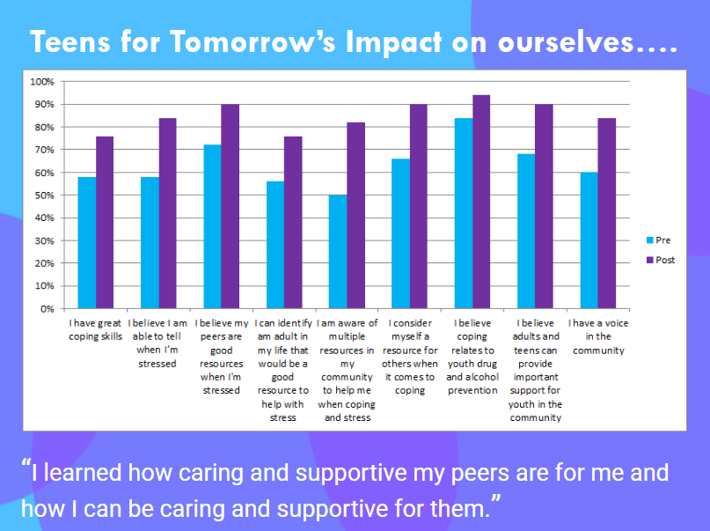

Note to Panel and Moderator

This panel was designed by 2019 Clark County Teens for Tomorrow Peer Educators.

Who is Teens for Tomorrow? We are a group of up to 30 youth from all over our county, ages 12-18, that promote awareness of the risks of drug and alcohol use through outreach and educational programs designed by us, all while being a resource for the youth in our community and in our school. We are also a big family and Teens for Tomorrow is a place you can feel safe and belong

This workshop is meant to be completed in approximately 45-75 minutes and can be done with a small group of 15 youth to a school assembly. Script can be adapted to however many presenters are interested and able to share.

Contact our program coordinator, Alaina Green, at Alaina.Green@clark.wa.gov for more information, clarification, further resources or support using the script.

You are free to alter, adapt, remove, or add to this script as needed to match the desires and goals of your audience and community. Please credit Teens for Tomorrow when you do. Sample video is available upon request

Thank you for your interest and partnership.

- Teens for Tomorrow 2019.

Moderator Script

INTRO (5 or 10 min)

Moderator: Hello everyone, how are you all doing today? (Pass out candy to those who respond) I said, how are you all doing today!? (Throw candy to crowd). My name is ______________ and these are some of my friends. Why don't you say your name, pronouns, school, grade, and one of your coping skills?

[Panelists share name, pronouns, school, grade, coping skill]

Mod: Thanks, everyone. Can I ask one of you to describe the group we’re a part of? (calls on volunteer)

Panelist #1 ______________: We are youth from Teens for Tomorrow. It’s a community volunteer organization based in Clark County. We educate ourselves to help educate our peers on the effects drug and alcohol use may have on teens and we work to promote healthy coping skills, while working with the power of prevention. We have a lot of fun and do important work like this panel. Teens for Tomorrow is a family for us all.

Mod: Thank you! (To audience) We are all so glad you’re here with us, and we can’t wait to begin.

We really appreciate you having us here today so we can share our Youth-2-Youth Panel Discussion. Not everyone knows exactly what a panel is: a panel discussion is a live, casual conversation where we have a few speakers, panelists, here who are prepared to share their ideas on specific topics and they may answer some questions as well. I am the moderator, meaning I will be keeping the conversation going and bridging the gap between audience and speakers.

Our panel discussion we wanted to share with you all is called “We Are Still Learning Too: A Youth-2-Youth Panel Discussion on Healthy Coping.” ______________, could you help me out with explaining some more about why we’re here this afternoon?

Panelist #2 ______________: Sure. During this panel our goal is that everyone learns the importance of healthy coping, which means taking care of yourself physically or mentally to better yourself. Healthy coping skills are the strategies people often use in the face of stress and/or trauma to help manage painful or difficult emotions. Coping mechanisms can help people adjust to stressful events while helping them maintain their emotional well-being. This can be things like hobbies, meditation, boundaries, breaks, talking, reaching out for support, etc. The panel is titled “We Are Still Learning Too” because we are also still learning how to cope and we wanted you to know you are not alone if you are still figuring it out.

Mod: Thanks ______________. A large portion of our youth in the community experience depression and anxiety. In 2016:
- 38% of Clark County 10th graders reported feeling sad or hopeless for at least two weeks in the past year
- 49% of 8th graders reported they have an adult to turn to when they feel sad or hopeless
- 66% of 10th graders reported feeling nervous, anxious, over the edge, or not being able to stop?

Mod: ______________, would you please give us a rundown on how those statistics relate to our conversation today?

Panelist #3 ______________: A large portion of our youth in the community experience depression and anxiety. This information worried us when we read it and we wanted to do something about it, so that is why we are doing a panel on healthy coping. It worried us because some of us identified that we are some of those statistics, and because we have friends and other youth in our community that are saying these things. We want to have an open conversation with our peers about making healthy coping and stress management a norm that we can talk about to each other and to adults in our community.

Mod: Thank you, ______________.

Mod: When you got here we gave you a pre-survey we created. If you could fill that out for us and fold those in ½ when you are done, that would be great. We will collect them in an envelope at the end. Don’t add your name to it. We will do a post-survey at the end too.

Mod: We’re almost ready to really jump into the panel, but before we do I want to create some shared agreements with all of you to make sure we can create a safe space here for everyone. This panel is open for vulnerability and we are prepared to share our truths and stories with all of you. We hope to be real with you all, and during this panel you will be listening to diverse life experiences and ideas about healthy coping.

Stories that may be shared here are expressions of trust. Please keep the personal things our panelists share today in this room, and please show your love and support by listening fully. Most of what you hear will be personal opinions, and you don’t have to agree with any of it. We are simply sharing our perspectives and are hoping that we all come away having learned something in the end.

We want you to know that we are mandatory reporters, which means that if we hear a story where we think someone underage may be in danger, we have to report it. Can I get a thumbs up from everyone so I know we’re all on the same page? Wonderful, thank you.

Now panelists, I am going to ask you questions and each of you can take turns answering. Let’s get started! Here’s a icebreaker question so the panelist can get comfortable: If they made a movie of your life, what would it be about and which actor would you want to play you?

Mod: Alright, here are our more serious questions and in relation to the theme of today and healthy coping.

- (7 min) What stresses you out? How do you know you’re stressed? How are you learning to cope with those stressors, like how are you coping?

- Signs of stress?
- Physical, patterns, mood, things you do
- Get deep!
- Tell stories of how you started to identify these indicators
- How did you find your coping skill
- How do you cope with different emotions(anger, sadness, loneliness, fear?)
- Scheduling time for self-care
- Working on talking about stuff, reading
- Importance of physical and emotional health, finding balance
- Crying as an indicator of stress

- (7 min) Panelists – you each introduced yourself with a coping skill that you use when you find yourself dealing with challenges in your life. I’m wondering if you could expand some more and describe what negative and positive coping skills look like for you?

- 1st answers to come to mind
- Short term-long term coping – why is it important to know the difference
- Distraction v. coping
- Focusing on helping others instead of yourself-distraction
- Volunteering as a way to gain independence
- Recognizing negative coping vs. positive coping

- (7 min) How do you know when to reach out for support when you are stressed? Who and what resources have you reached out to?

- What are things your peers can help you with that adults can’t? What are things adults can help you with that peers can’t?
- Boundaries
- When is something too big for youth to handle and should reach out to an adult?
- Favorite resources (counselor/hotline/group/organization/faith) and share a story of when they helped you
- Share a story of when an adult helped you through a tough time and what was helpful
- Share a story of a time a peer helped you and what did they do that helped
- How do you talk to adults about tough stuff? Tips?
- Do you know what your best friend’s coping skills are and are they different than yours? How did you figure out what their coping skills were?
- Share story of finding 741741 number
- Finding adult support in addition to parents
- Experience with hotlines and warmlines

- (7 min) What bit of advice would you like to give everyone in the room that might be struggling with tough times and feeling alone? What is the main takeaway you hope everyone gets from this discussion?

- You are not alone, even when it feels like it. You have someone. Please reach out to those people. You do not have to feel good. It’s okay to feel alone. It’ll pass and you’ll feel better.
- Connection is the best prevention…what does that saying mean to you?
- It’s okay to hit milestones or process trauma at your own pace

- (7 min) You all are Teens for Tomorrow Peer Educators—a group of youth in Clark County working to educate your peers on drug and alcohol prevention. So my question is…How does coping relate to youth substance prevention?

- Relationship between drugs and mental health

(5 min) Ok—we have some time here to open it up to the audience for questions. Is there anyone who has a question for our panelist around healthy coping?

CONCLUSION (10 min)

Mod: Let’s give a big round of applause to our amazing panelists! We appreciate your vulnerability and willingness to share who you are with all of us today.

Personally, a key takeaway for me from this panel was __________, Could a couple of you (point to audience) share key takeaways within 5 words? (Call on about three people and thank them for sharing takeaways when they finish)

We hope that all of you will leave today with confidence and understanding in self-care. Remember the importance of taking care of yourself and use the advice given today through the most difficult of times. We will all be here to support and encourage you. Before we conclude, we have a post survey for you to all take 2-5 minutes filling it out and __________ will collect them in their envelope so we can see if this panel was helpful in increasing skills for coping. It is all anonymous and we really appreciate your help!

A huge thank you to all of our amazing partners: (organization hosting panel) ____________________! We could not have put together this panel without your support. Another huge thank you to all of you! None of us would be here without you. The respect, care, and support you show us inspire us very day, so thank you!

That’s the end of our panel discussion. We are also looking for people to join our Teens for Tomorrow group next school year (pass out application) and we have applications here if you would like to apply.

All panelists are available for questions if you have any as we conclude. Thank you all so much, we hope to see you again soon!

Tips for Panelists

#1: It’s great to make your stories as specific as possible, including details about who you turned to for help (for example) or how you felt/thought about a situation. It makes you really relatable and it will be extra helpful for anyone facing a similar situation.

#2: It’s okay to stumble over answers! It shows that you’re speaking from the heart and being genuine and honest, and it will help give confidence to audience members who are nervous about speaking up. If you’re not perfect and you can do it, why can’t they?

#3: If you’re not sure you came across well, you can ask, “did that make sense?” This will cue the moderator to paraphrase what you said, and give you the opportunity to either agree completely if they hit the nail on the head, or take what they say and build off of it to make your statement more clear.

#4: It’s normal to feel uncomfortable or unnatural speaking to a crowd like this, but try to take a deep breath and act as naturally YOU as you can! Remember that you are talking with your friends, and it’s okay to make hand gestures, snort-laugh, crack jokes, and have good energy, as long as you’re being respectful of your fellow panelists (so maybe don’t make bunny ears behind the person next to you, but nod your head and smile and pat the back of your fellow panelist).

#5: Dust off all of your active listening skills! If you’re not the panelist answering the question, look toward whoever is speaking and stay engaged. Listen intently, nod your head when you agree with something, etc. By doing this, you’re not only showing your love and support for your panel buddies, you are being a good role model for the audience and helping them direct their attention to the right person.

#6: If you’re speaking, be sure to keep an on eye the moderator. Time is really limited, and they may need to give you a signal to finish your comment so the panel can move forward. If you do see a signal, you can acknowledge it with a head nod so they know you saw them.

#7: Extra credit, but not essential: when you’re speaking, you can keep the audience engaged by making eye contact with different audience members for a second or two at a time, and try not to talk to just one section of the audience (unless you’re responding to someone’s specific question).

#8: It’s okay to take care of yourself, we have learned this panel is full of heavy stuff. You can avoid questions you don’t want to answer. Some topics that come up could be difficult, and your first job is to take care of yourself and make sure that you’re okay with everything. Your teammates have your back and, if you need to, you can step out to take care of yourself. You have permission.

#9: If someone asks you a question that you don’t know the answer to, it’s OK to be honest and say you don’t know. If you can think of any good resources where the asker might be able to find the answer, feel free to share. Other panelists and the moderator can jump in to help.

#10: Avoid telling triggering stories. Your experiences are really important, but we don’t know who’s in the audience and what struggles they might be having. If you are unsure if something is triggering, check in with someone before the panel.
#11: If someone asks a question that is out of your depth (i.e., about suicide, etc) it’s important to validate their question (“Wow, that sounds like a really difficult situation to be in,” “That’s really brave of you to share. Thank you for trusting us”) and then suggest a couple of resources appropriate for the situation they’re in. Let them know you are not an expert in that and suggest things like reaching out to staff, a suicide warm line or hotline, Clark County TeenTalk, talking to a trusted adult, etc

#12: In the unlikely case someone asks a question that’s inappropriate, you do NOT have to answer. Staff members will step in and handle it before you have to.

#13: Remember your goals for the panel: share resources, help youth identify a supportive adult, identify one short-term and one long-term coping skill, feel more comfortable to share real struggles with safe people and ask for support.

#14: Feel free to help out your fellow panelists if they’re struggling to think of a word or example. Your moderator will also be available to help out.

#15: Be sure to give other people space to share. We want our audience to hear diverse perspectives, so if you find yourself speaking up a lot, try to give other members of the group an opportunity to chime in.

#16: Make sure you avoid making judgements during your stories, whether it’s about teachers, parents, peers, etc. Stay positive!

#17: Please keep your phones on silent! There’s a parallel universe where your phone goes off in the middle of the panel REALLY LOUDLY and you’re very embarrassed. Do your future self a favor and avoid that possibility entirely.

#18: Please avoid shuffling your papers while other people are talking! Paper noises are very distracting and make it hard for the audience to hear the panelist who’s speaking.

#19: After the event, stick around so we can debrief as a group!

Tips for Moderator(s)

#1: Fall into the background! Once you’ve set your panelists up for success by explaining everything, your job is main job is to help them shine. If you start feeling like the center of attention, it’s time to redirect towards the panelists.

#2: If a panelist is struggling to find a word or example, feel free to help them out!

#3: A panelist might not feel like they’re getting their point across. If they ask “did that make sense?” that’s an invitation for you to help them out by paraphrasing what you think they’re trying to say. Hopefully that will help them figure it all out, either by agreeing with you or taking what you said and building off of it.

#4: Keep the vibe positive and the conversation flowing by transitioning between comments with validating statements. For example, “That was insightful,” “thank you for sharing,” “wow, anyone else like to add to that?”

#5: When you address a panelist, it’s helpful to say their name. Examples: “Sam, what do you think?” “Great advice, Bianca.” “Remy, you have a great story about dealing with parents that I’ve heard before. Could I ask you to share it?” This helps keep the dialogue moving; it removes confusion about who you’re talking to, especially if you’re transitioning from one person to the next; it helps the panelists follow the conversation; and it helps you give credit where credit is due (“Jasmin, I think that was a really thoughtful response to Robin’s story”)

#6: Don’t be afraid to repeat questions! If someone shares for a long time, it’s helpful for both the panelists and audience to have a brief version of the question again. For example, if someone finishes talking and you see someone else who wants to answer, you could thank the person who just finished and transition by saying something like “Merle, what’s your advice for everyone who might be struggling or feeling alone?”

#7: Time is limited. It’s okay to keep things moving if too much time is going towards one question, or if a panelist is accidentally going over their time limit. You’ll need to keep your eye on the time, and staff will keep time in the audience as backup. It’s okay to skip questions (but please make sure to cover question 6).

#8: If you need to move onto the next question, it’s okay to give the panelist speaking a subtle signal like a nod or touching your watch (or wrist where your watch would be). If you have to, you can jump in and say something like “hey, I’m sorry but I have to interrupt you. Unfortunately we have to move on to the next question.” Use your best judgement, not everything has to go like clockwork. The panelists know that there’s only so much time, and they’ll appreciate you keeping things on track!

#9:During audience Q&A, it’s a good idea to repeat audience questions so that everyone in the audience (including the panelists) can hear.

#10: Remember to put your phone on silent! It’s always the one time that you forget to silence your phone that you get pocket-dialed by person who has the loudest and most embarrassing ringtone.

Pre/Post Survey

How much do you agree with these statements?

 | Super agree (1) | Kinda agree (2) | Sort of agree (3) | Not really agree (4) | Don't agree at all (5)
1) I have great coping skills
2) I believe I am able to tell when I’m stressed
3) I believe my peers are good resources when I’m stressed
4) I can identify am adult in my life that would be a good resource to help with stress
5) I am aware of multiple resources in my community to help me when coping and stress
6) I consider myself a resource for others when it comes to coping
7) I believe coping relates to youth drug and alcohol prevention
8) Coping has helped me or can help me with mental health
9) I believe adults and teens can provide important support for youth in the community
10) I have a voice in the community

